Let’s simplify this explanation and add some examples for better understanding.

**Box Plot Basics**

A box plot is a chart that shows how data is spread out. It helps you see the middle of the data, how far the data spreads, and if there are any extreme points (called outliers).

**1. Whiskers in a Box Plot**

The whiskers are the "lines" that stretch out from the main box. They show how far the data goes, excluding any extreme points (outliers).

* **Lower whisker**: Starts from the **lower quartile (Q1)** and extends to the smallest value that’s not an outlier.
* **Upper whisker**: Starts from the **upper quartile (Q3)** and extends to the largest value that’s not an outlier.

**Example**: Imagine we have test scores from a class:

* **Whiskers** will stretch from the 25th percentile to the lowest non-outlier score and from the 75th percentile to the highest non-outlier score.

**2. Quartiles in a Box Plot**

Quartiles divide the data into four equal parts.

* **Lower quartile (Q1)**: This is the point below which 25% of the data falls.
* **Upper quartile (Q3)**: This is the point below which 75% of the data falls.

The box in a box plot shows the range from the **lower quartile (Q1)** to the **upper quartile (Q3)**, which contains the middle 50% of the data.

**Example**: In our test score example, if the lower quartile is 60 and the upper quartile is 80, then half of the students scored between 60 and 80.

**3. LQR (Lower Quartile Range)**

The **Lower Quartile Range (LQR)** is the value of the **lower quartile (Q1)** itself, which is the 25th percentile.

More commonly, we use the **Interquartile Range (IQR)**, which is the range between the **upper quartile (Q3)** and the **lower quartile (Q1)**. This measures how spread out the middle 50% of the data is.

IQR=Q3−Q1\text{IQR} = Q3 - Q1IQR=Q3−Q1

**Example**: If in our test score example, Q1 is 60 and Q3 is 80, then the IQR is 80−60=2080 - 60 = 2080−60=20, meaning the middle 50% of the test scores are spread across a 20-point range.

**Key Components of a Box Plot**

Here’s what each part of a box plot represents:

* **Minimum**: The smallest data point (not an outlier).
* **Lower Quartile (Q1)**: The value below which 25% of the data falls.
* **Median**: The middle value of the data (50th percentile).
* **Upper Quartile (Q3)**: The value below which 75% of the data falls.
* **Maximum**: The largest data point (not an outlier).
* **Whiskers**: Extend from the lower quartile to the smallest value and from the upper quartile to the largest value that’s not an outlier.
* **Outliers**: Data points that are very different from the rest of the data (they fall outside 1.5 times the IQR).

**Example Walkthrough**

Imagine we have a set of test scores:

* **Minimum**: 50
* **Q1 (Lower Quartile)**: 60
* **Median**: 70
* **Q3 (Upper Quartile)**: 80
* **Maximum**: 100
* **Outlier**: 110 (a student scored much higher than the rest)

In the box plot:

* The box goes from 60 (Q1) to 80 (Q3), showing that the middle 50% of scores are between 60 and 80.
* The line inside the box at 70 shows the median score.
* The whiskers go from 50 (the smallest score that isn’t an outlier) to 100 (the largest non-outlier score).
* The outlier at 110 is shown as a point beyond the upper whisker.

Would you like a diagram with this example included?

Let's dive deeper into **quartiles** and how they are represented in a **box plot**, with a focus on each quartile's meaning and role, using a graph-based example.

**What are Quartiles?**

Quartiles are statistical values that divide a dataset into four equal parts, where each part contains 25% of the data. Quartiles help you understand the distribution of data and are often used to visualize the spread of a dataset.

The three main quartiles are:

1. **Lower Quartile (Q1)** – Also called the **25th percentile**, where 25% of the data lies below this value.
2. **Median (Q2)** – Also called the **50th percentile**, where 50% of the data lies below this value (middle of the dataset).
3. **Upper Quartile (Q3)** – Also called the **75th percentile**, where 75% of the data lies below this value.

**In-Depth Explanation of Quartiles in a Box Plot**

1. **Lower Quartile (Q1)**:
   * This is the point where **25% of the data** falls below and **75% of the data** falls above.
   * In the box plot, the **lower edge of the box** marks **Q1**.
   * The **lower whisker** starts at Q1 and extends to the **smallest non-outlier value**.

**Example**: If you have a dataset of exam scores, and Q1 is 60, it means that 25% of the students scored **below 60**, and 75% scored **above 60**.

1. **Median (Q2)**:
   * The median is the **middle value** of the dataset, where **50% of the data** falls below it and **50% falls above it**.
   * The **line inside the box** represents the median in a box plot.

**Example**: Continuing with the exam score example, if the median (Q2) is 70, it means half the students scored **below 70**, and the other half scored **above 70**.

1. **Upper Quartile (Q3)**:
   * This is the point where **75% of the data** falls below and **25% falls above**.
   * The **upper edge of the box** represents **Q3** in a box plot.
   * The **upper whisker** starts at Q3 and extends to the **largest non-outlier value**.

**Example**: In the exam score dataset, if Q3 is 80, it means that 75% of the students scored **below 80**, and only 25% scored **above 80**.

**Interquartile Range (IQR):**

The **IQR** measures the spread of the middle 50% of the data and is calculated as:

IQR=Q3−Q1IQR = Q3 - Q1IQR=Q3−Q1

* The IQR is the range between the **lower quartile (Q1)** and the **upper quartile (Q3)**.
* It helps to understand the data spread and identify outliers.

**Example**: If Q1 is 60 and Q3 is 80, the IQR is 80−60=2080 - 60 = 2080−60=20, meaning the middle 50% of the exam scores are spread across 20 points.

**Whiskers in a Box Plot:**

* The **lower whisker** extends from Q1 to the **smallest value** that is not considered an outlier.
* The **upper whisker** extends from Q3 to the **largest value** that is not considered an outlier.

**Outliers:**

Outliers are data points that fall **outside 1.5 times the IQR**. They are typically shown as individual points beyond the whiskers.

**Example with Graph Explanation**

Let’s create an example based on this data:

| **Student** | **Score** |
| --- | --- |
| A | 50 |
| B | 55 |
| C | 60 |
| D | 65 |
| E | 70 |
| F | 75 |
| G | 80 |
| H | 85 |
| I | 90 |
| J | 95 |

1. **Q1** (25th percentile) is 60, meaning 25% of students scored below 60.
2. **Median (Q2)** is 70, the middle score, splitting the data into two equal halves.
3. **Q3** (75th percentile) is 80, meaning 75% of students scored below 80.

In this case:

* The **IQR** is Q3−Q1=80−60=20Q3 - Q1 = 80 - 60 = 20Q3−Q1=80−60=20.
* The **lower whisker** extends from 60 (Q1) to 50 (the smallest score).
* The **upper whisker** extends from 80 (Q3) to 95 (the largest score).

I will now create a diagram based on this example to illustrate the quartiles and whiskers of this data set.

In the example you've shown, the **Interquartile Range (IQR)** is calculated as follows:

IQR=Q3−Q1=80−60=20\text{IQR} = Q3 - Q1 = 80 - 60 = 20IQR=Q3−Q1=80−60=20

**Breakdown of the Calculation:**

* **Q1 (Lower Quartile)**: This is the 25th percentile of the data, which is given as 60.
* **Q3 (Upper Quartile)**: This is the 75th percentile of the data, which is given as 80.
* To calculate the **IQR**, subtract the **lower quartile (Q1)** from the **upper quartile (Q3)**: IQR=Q3−Q1=80−60=20IQR = Q3 - Q1 = 80 - 60 = 20IQR=Q3−Q1=80−60=20

This tells us that the range of the middle 50% of the data is 20 points wide, between scores of 60 and 80.

**Whisker Calculations:**

* The **lower whisker** extends from **Q1 (60)** to the **smallest value** that’s not considered an outlier. In this example, the smallest value is 50.
* The **upper whisker** extends from **Q3 (80)** to the **largest value** that’s not considered an outlier. In this example, the largest value is 95.

Would you like further clarification or additional calculations on this?

How this 50 and 95 is calculated

The values **50** and **95** are not directly calculated from quartiles; they are taken from the dataset as the **minimum** and **maximum** values that are **within the acceptable range**, which excludes outliers.

### Here's how the process works:

#### ****1. Finding the Lower Whisker (50 in this case):****

* The lower whisker extends from **Q1** (the 25th percentile, here 60) to the **smallest value** in the dataset that is **not an outlier**.
* To find the cutoff for outliers, we use the **1.5 times the Interquartile Range (IQR)** rule.

Lower Bound=Q1−1.5×IQR\text{Lower Bound} = Q1 - 1.5 \times IQRLower Bound=Q1−1.5×IQR

* + In this case: Lower Bound=60−1.5×20=60−30=30\text{Lower Bound} = 60 - 1.5 \times 20 = 60 - 30 = 30Lower Bound=60−1.5×20=60−30=30
  + Any value below 30 would be considered an outlier. Since **50** is larger than 30, it is within the range and becomes the **lower whisker** value.

#### ****2. Finding the Upper Whisker (95 in this case):****

* The upper whisker extends from **Q3** (the 75th percentile, here 80) to the **largest value** in the dataset that is **not an outlier**.
* Again, we use the **1.5 times the IQR** rule to find the cutoff for outliers:

Upper Bound=Q3+1.5×IQR\text{Upper Bound} = Q3 + 1.5 \times IQRUpper Bound=Q3+1.5×IQR

* + In this case: Upper Bound=80+1.5×20=80+30=110\text{Upper Bound} = 80 + 1.5 \times 20 = 80 + 30 = 110Upper Bound=80+1.5×20=80+30=110
  + Any value above 110 would be considered an outlier. Since **95** is smaller than 110, it is within the acceptable range and becomes the **upper whisker** value.

### Summary:

* The **lower whisker** extends to the smallest value in the data that is not below the lower bound (in this case, 50).
* The **upper whisker** extends to the largest value in the data that is not above the upper bound (in this case, 95).

Outliers (data points outside the bounds) are shown separately as individual points beyond the whiskers.

Would you like me to generate a box plot based on this example to visualize it?

In this table and explanation, we are working with the scores of students. The table provides the data, and from it, we can calculate key statistics such as quartiles and the median. Let’s break down each step to explain the calculations in detail.

**Data:**

| **Student** | **Score** |
| --- | --- |
| A | 50 |
| B | 55 |
| C | 60 |
| D | 65 |
| E | 70 |
| F | 75 |
| G | 80 |
| H | 85 |
| I | 90 |
| J | 95 |

**1. Calculating the Quartiles and Median:**

To calculate **Q1**, **Q2 (median)**, and **Q3**, the data needs to be sorted, which it already is in the table.

* **Q1 (25th percentile)**:
  + The **lower quartile (Q1)** is the value where **25%** of the data lies below it.
  + In a list of 10 values, Q1 is located at the position 0.25×(n+1)0.25 \times (n+1)0.25×(n+1), where nnn is the number of data points.
  + Q1Q1Q1 is at the (0.25×11)=2.75(0.25 \times 11) = 2.75(0.25×11)=2.75-th position, so we take an average between the 2nd and 3rd values (55 and 60).

Q1 = \frac{55 + 60}{2} = 57.5 ] Therefore, **Q1 = 57.5**.

* **Q2 (Median, 50th percentile)**:
  + The **median** is the middle value, where **50%** of the data falls below it.
  + Since we have an even number of values (10), the median is the average of the 5th and 6th values (70 and 75).

Q2 = \frac{70 + 75}{2} = 72.5 ] Therefore, **Q2 = 72.5**.

* **Q3 (75th percentile)**:
  + The **upper quartile (Q3)** is the value where **75%** of the data falls below it.
  + In a list of 10 values, Q3 is located at the position 0.75×(n+1)0.75 \times (n+1)0.75×(n+1), where nnn is the number of data points.
  + Q3Q3Q3 is at the (0.75×11)=8.25(0.75 \times 11) = 8.25(0.75×11)=8.25-th position, so we take an average between the 8th and 9th values (85 and 90).

Q3 = \frac{85 + 90}{2} = 87.5 ] Therefore, **Q3 = 87.5**.

**2. Calculating the Interquartile Range (IQR):**

The **IQR** is the range between the **upper quartile (Q3)** and the **lower quartile (Q1)**. It measures the spread of the middle 50% of the data.

IQR=Q3−Q1=87.5−57.5=30\text{IQR} = Q3 - Q1 = 87.5 - 57.5 = 30IQR=Q3−Q1=87.5−57.5=30

**3. Whiskers and Outliers:**

* The **lower whisker** typically extends to the smallest value that is **not an outlier**, while the **upper whisker** extends to the largest value that is **not an outlier**.
* To determine the outlier boundaries:
  + **Lower bound**:

Q1−1.5×IQR=57.5−1.5×30=57.5−45=12.5Q1 - 1.5 \times \text{IQR} = 57.5 - 1.5 \times 30 = 57.5 - 45 = 12.5Q1−1.5×IQR=57.5−1.5×30=57.5−45=12.5

Any value below 12.5 would be considered an outlier, but there are no values below this.

* + **Upper bound**:

Q3+1.5×IQR=87.5+1.5×30=87.5+45=132.5Q3 + 1.5 \times \text{IQR} = 87.5 + 1.5 \times 30 = 87.5 + 45 = 132.5Q3+1.5×IQR=87.5+1.5×30=87.5+45=132.5

Any value above 132.5 would be considered an outlier, but there are no values above this.

**4. Summary of the Calculations:**

* **Q1 (Lower Quartile)**: 57.5
* **Q2 (Median)**: 72.5
* **Q3 (Upper Quartile)**: 87.5
* **IQR**: 30
* **Lower Bound**: 12.5
* **Upper Bound**: 132.5

In this example, no data points are outliers. The **lower whisker** will extend to 50 (the minimum score), and the **upper whisker** will extend to 95 (the maximum score).

Would you like a visual representation (box plot) based on these calculations?

Box Plot of Student Scores

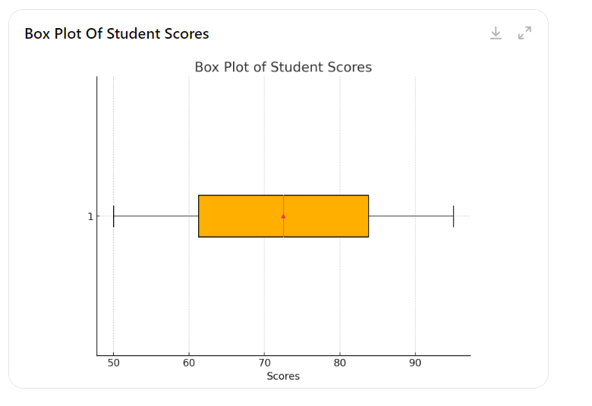

Here is the visual representation of the box plot based on the student scores:

* The **box** represents the interquartile range (IQR), from **Q1 (57.5)** to **Q3 (87.5)**.
* The **median (Q2 = 72.5)** is represented by the line inside the box.
* The **whiskers** extend from the minimum value (50) to the maximum value (95).
* No outliers are present in this dataset.

This box plot summarizes the distribution of the student scores visually. Let me know if you need further clarification or adjustments! ​

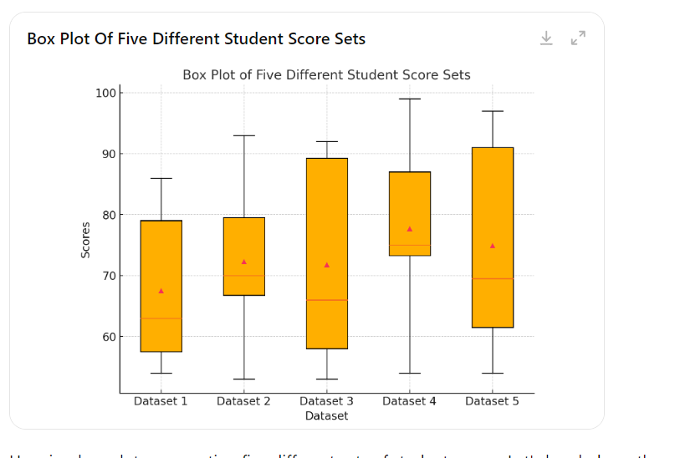

Here is a box plot representing five different sets of student scores. Let's break down the explanation for one of these datasets as an example, similar to the previous explanation. I'll also summarize the overall interpretation for all five datasets.

**Example Dataset:**

For **Dataset 1**: [54, 54, 56, 62, 63, 63, 76, 80, 81, 86]

**1. Calculating Quartiles and Median for Dataset 1:**

* **Q1 (25th percentile)**: The 25th percentile is between the 2nd and 3rd values (54 and 56), so: Q1=54+562=55Q1 = \frac{54 + 56}{2} = 55Q1=254+56​=55
* **Q2 (Median, 50th percentile)**: The median is between the 5th and 6th values (63 and 63), so: Q2=63+632=63Q2 = \frac{63 + 63}{2} = 63Q2=263+63​=63
* **Q3 (75th percentile)**: The 75th percentile is between the 8th and 9th values (80 and 81), so: Q3=80+812=80.5Q3 = \frac{80 + 81}{2} = 80.5Q3=280+81​=80.5

**2. Calculating the Interquartile Range (IQR) for Dataset 1:**

IQR=Q3−Q1=80.5−55=25.5\text{IQR} = Q3 - Q1 = 80.5 - 55 = 25.5IQR=Q3−Q1=80.5−55=25.5

**3. Whiskers and Outliers for Dataset 1:**

* **Lower bound**:

Q1−1.5×IQR=55−1.5×25.5=55−38.25=16.75Q1 - 1.5 \times IQR = 55 - 1.5 \times 25.5 = 55 - 38.25 = 16.75Q1−1.5×IQR=55−1.5×25.5=55−38.25=16.75

There are no values below 16.75, so no lower outliers.

* **Upper bound**:

Q3+1.5×IQR=80.5+1.5×25.5=80.5+38.25=118.75Q3 + 1.5 \times IQR = 80.5 + 1.5 \times 25.5 = 80.5 + 38.25 = 118.75Q3+1.5×IQR=80.5+1.5×25.5=80.5+38.25=118.75

There are no values above 118.75, so no upper outliers.

**Summary of Dataset 1:**

* **Q1**: 55
* **Q2 (Median)**: 63
* **Q3**: 80.5
* **IQR**: 25.5
* **Lower Bound**: 16.75
* **Upper Bound**: 118.75
* **No outliers** in Dataset 1. The whiskers extend to 54 (minimum) and 86 (maximum).

**Overall Observations for All Five Datasets:**

* **Dataset 2** has a wider spread with values between 53 and 93, and a median around 70.
* **Dataset 3** shows a more skewed distribution with higher values in the upper range (87 to 92), reflecting higher scores.
* **Dataset 4** has a smaller interquartile range (from 73 to 88), indicating more consistency in scores.
* **Dataset 5** has a wide spread, similar to Dataset 1, with no outliers and a range of values from 54 to 97.

Would you like a deeper breakdown for each dataset or additional modifications? ​